Name of young person

Notes

How confident are you feeling about yourself?
I know the things I am good at and enjoy doing them
Never Very Hardly Not often Sometimes Often Very often Nearly Always
rarely ever always

I enjoy trying to do new things
Never Very Hardly Not often Sometimes Often Very often Nearly Always
rarely ever always

I am good at asking for help
Never Very Hardly Not often Sometimes Often Very often Nearly Always
rarely ever always

I can cope well in new and unexpected situations
Never Very Hardly Not often Sometimes Often Very often Nearly Always
rarely ever always

I am comfortable meeting new people

Never Very Hardly Not often Sometimes Often Very often Nearly Always
rarely ever always

How are you feeling about yourself?
On the whole, I am satisfied with myself
Never Very Hardly Not often Sometimes Often Very often Nearly Always
rarely ever always

At times I think I am no good at all. (Note scale changes)
Always Nearly Very often Often Sometimes Not often Hardly Very rarely Never
always Ever

I can do things as well as most other people.
Never Very Hardly Not often Sometimes Often Very often Nearly Always
rarely ever always

Sometimes I feel I can’t do anything well. (Note scale changes)
Always Nearly Very often Often Sometimes Not often Hardly Very rarely Never
always Ever

I take a positive attitude towards myself.
Never Very Hardly Not often Sometimes Often Very often Nearly Always
rarely ever always

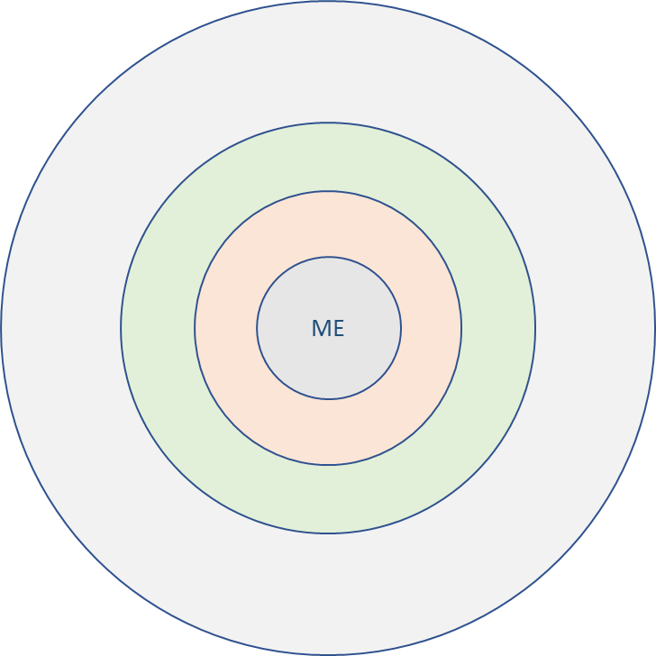
Talk about the people you know:

People who care about me (inner circle)
People I can talk to about anything (second circle)
People I really like being with (third circle)
People I talk to and play games with (outer circle)
What do you do locally?

