Name of young person

Notes

How confident are you feeling about yourself?
I know the things I am good at and enjoy doing them
Strongly disagree Strongly agree

I enjoy trying to do new things
Strongly disagree Strongly agree

I am good at asking for help
Strongly disagree Strongly agree

I can cope well in new and unexpected situations
Strongly disagree Strongly agree

I am comfortable meeting new people

Strongly disagree Strongly agree

How are you feeling about yourself?
On the whole, I am satisfied with myself
Strongly disagree Strongly agree

At times I think I am no good at all.
Strongly agree Strongly disagree

I can do things as well as most other people.
Strongly disagree Strongly agree

Sometimes I feel I can’t do anything well.
Strongly agree Strongly disagree

I take a positive attitude towards myself.
Strongly disagree Strongly agree

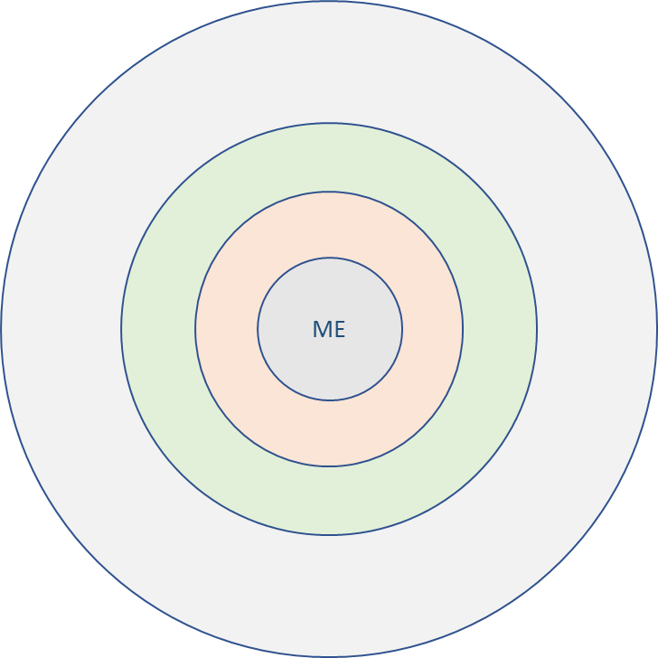
Talk about the people you know:

People who care about me (inner circle)
People I can talk to about anything (second circle)
People I really like being with (third circle)
People I talk to and play games with (outer circle)
What do you do locally?

