**Adverse Childhood Experiences (ACES) briefing**

**1. What are ACEs?**

Adverse Childhood Experiences (ACEs) refer to stressful events occurring in childhood (between 0 to 18 years) including:

* being the victim of abuse (physical, sexual and/or emotional) or neglect (physical and emotional), and
* growing-up in a household in which there are adults experiencing alcohol and drug use problems, mental health conditions, domestic violence or criminal behavior resulting in incarceration.

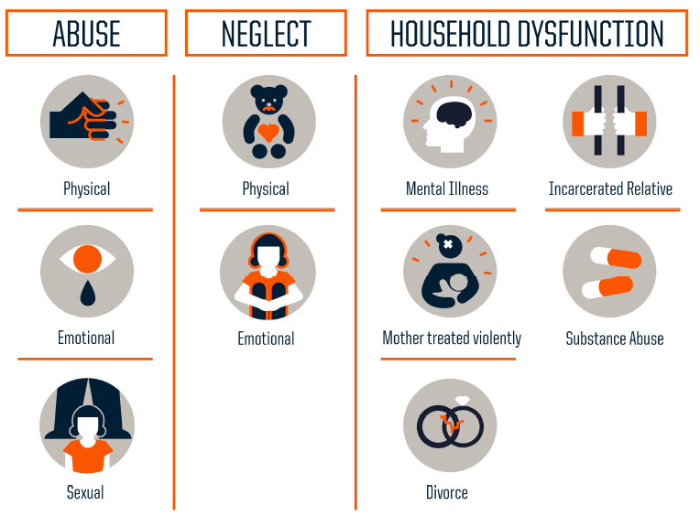

Source: <http://www.rwjf.org/en/library/infographics/the-truth-about-aces.html>

The term Adverse Childhood Experiences (ACEs) was originally developed in the 1990s in a US survey[1] about childhood maltreatment, family dysfunction, current health status and behaviours. This ACE survey was used to calculate an ACE score out of 10 (see Annex A for an example of ACE questions). This question set had been adapted for use in subsequent surveys across different countries (including England and Wales). There are other types of childhood trauma (e.g. extreme poverty, bereavement, bullying) that can have the same negative effects and some studies are incorporating other types of trauma depending on the populations they are looking at.

Traumatic childhood events such as abuse, neglect, parental conflict, mental illness, and substance abuse can create harmful levels of stress which impact healthy brain development—resulting in long-term effects on learning, behavior and health. Neurobiological research indicates that the ‘toxic stress’[2] associated with ACEs leads to physical changes in the way the brain develops and people’s propensity to experience future stress, adopt health harming behaviours and develop mental and physical illness[3],[4]*.* Section three outlines the impacts of ACEs.

**2. How prevalent are ACEs?**

The original US study found that ACEs were common, with almost two-thirds of participants experiencing at least one ACE and more than 1 in 5 experiencing 3 or more ACEs[5],1. In a representative English survey, almost 50% reported experiencing a least one ACE and over 8% reported experiencing 4 or more1. In the Welsh survey, almost 50% of people reported experiencing at least one ACE and 14% reported experiencing four or more1,[6] . The Welsh survey found1,3:

* 23% had experienced verbal abuse
* 17% had experienced physical abuse
* 10% had experienced sexual abuse
* 20% had experienced parental separation
* 16% domestic violence
* 14% has a parent with a mental illness
* 14% parental alcohol abuse
* 5% parental drug use
* 5% had a parent in prison

Although these studies found ACEs were reported across the whole population, having high numbers of ACEs was found to be related to deprivation, with higher proportions of people in the most deprived quintile reporting 4 or more ACEs. Although reported health-harming behaviours were shown to increase with deprivation, the studies also found a relationship between ACEs and health-harming behaviour that was independent of deprivation1.

There have been no Scottish ACE surveys to date. It is reasonable to assume, however, that prevalence would be similar to England or Wales1. Recent analysis* of Growing Up in Scotland (GUS) Survey data explored the prevalence of ACEs reported in this longitudinal birth cohort study (it was possible to analyse 7 out of the original 10 ACEs questions)[7]. \**This analysis is currently under BMJ review so the findings cannot not be used or reported more widely at this stage.*

**3. What impacts do ACEs have?**

ACEs are experiences during the first 18 years of life, but the evidence demonstrates that ACEs exert an influence throughout the life-course (see diagram below). Consideration of ACEs is crucial to thinking about how to improve the lives of children and young people, to support better transitions into adulthood, and achieve good outcomes for all adults.

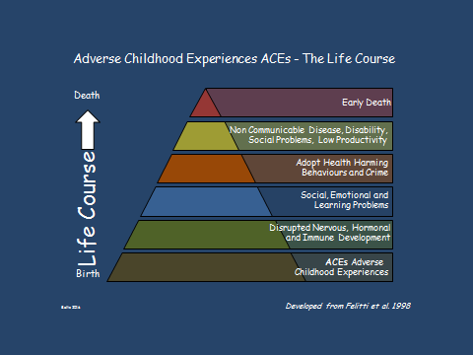

Source: Professor Mark Bellis, Public Health Wales3

**3.1 Impacts for young people**

Young people with ACEs face greater challenges in maintaining good physical and mental health and achieving ‘positive destinations’ in education and employment. ACEs have been shown to have the following impacts for young people:

**School** -ACEs can lead to greater anxiety in school and becoming a disengaged and poor learner3. There is significant evidence linking childhood maltreatment with poor educational outcomes, including: lower language and maths test scores, lower educational attendance, lower rates of graduating school[8]. The Washington State Family Policy Council (USA) initiative in schools found that ACEs were the best predictor of health, attendance and behaviour and that educational success was more related to ACEs than income3.

**Employment and income** - There is evidence that ACEs can impact on future employment and earning potential5. For example, maltreated children have been found to be more likely to have menial or semi-skilled jobs as young adults and are more likely to be unemployed than their non-maltreated peers5. There is also evidence of an association between maternal mental health and children’s educational attainment and future household income5.

**Health** - ACEs have been shown to be related to the risk of developing a mental illness whilst still in childhood (e.g. in a US study of 12-17 year olds the prevalence of a mental health problem rose from 11% in children experiencing no ACES to 44% in those having experienced five or more ACEs)1. ACEs are associated with greater risk of early initiation of sexual activity and with adolescent pregnancy1.

**Crime and violence** - Experience of ACEs can lead to young people misreading visual cues in other people’s faces, so that neutral cues can look threatening potentially leading to inappropriate responses3. Exposure to childhood adversity is associated with lack of empathy, impulsivity and anger, and the emergence of behavioural problems, including delinquency and social alienation[9]. Particularly damaging impacts have been observed for children of incarcerated parents, for example, 65% of boys with a convicted parent go on to offend themselves[10].

**3.2 Impacts in adulthood**

ACEs lead to a range of poorer health (physical and mental) and life outcomes (education, employment and crime). ACEs have been found to be associated with1:

* **poorer mental wellbeing** (e.g. risk of low life satisfaction and low mental wellbeing have been shown to increase with the number of ACEs experienced)
* **mental illness** (e.g.the role of ACEs such as abuse and neglect appear to have a strong effect on the development of Borderline Personality Disorder)
* **physical illness** (e.g. strong relationship between number of ACEs and the risk of developing disease and major illness)
* **risky health behaviours** (e.g. people who have experienced 4 or more ACEs were almost 4x more likely to smoke and to drink heavily compared to people with no ACEs)
* **premature mortality** (e.g. men who had experienced 2 or more ACEs had a 57% increased risk of death than men who had experienced no ACEs)
* **suicide** (e.g. increased suicide risk has been shown to be linked to the presence of childhood adversity by age seven)
* **being a perpetrator of crime** (e.g. people who have experienced 4 or more ACEs were almost 9x more likely to be incarcerated compared to people with no ACEs)
* **being a victim of crime** (e.g. people with ACEs have been found to be at greater risk of intimate partner violence)
* **education/employment** (e.g. those with higher ACEs have been found to be at greater risk of poorer educational and employment outcomes)

The recent National Study of ACEs in Wales (18 to 69 years) found that people with ACEs were much more likely to engage in risky behaviours and be a victim or perpetrator of crime and to be much more likely to experience low mental wellbeing and problems relating to others (see diagrams below)1,3. These effects were found to be independent of poverty.



Source: Public Health Wales



Source: Public Health Wales

**4. What can be gained from a policy and service focus on ACEs?**

As outlined from the evidence above, ACEs are leading to poorer public service outcomes (e.g. poorer educational outcomes) and leading to more demand on our public services (e.g. health, police and other justice services). For example, ACEs have been linked to greater risk of A&E attendance3 and in-patient hospital care1. Estimates based on Welsh survey data (see diagram below) suggest considerable health and economic gains from a focus on preventing or reducing ACEs1,3). A leading UK expert on ACEs, Professor Bellis, has argued that preventing ACEs could not only lead to healthier, happier children, but also increase mental wellbeing and employability and reduce inequalities and non-communicable disease3. There would be significant associated cost-savings from eradicating, or at least reducing, ACEs1.

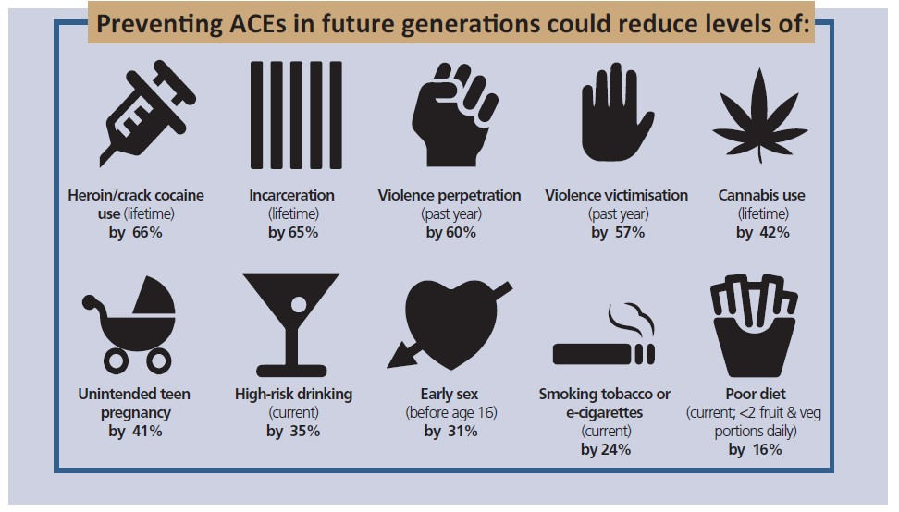

Source: Professor Mark Bellis, Public Health Wales3

**5. What actions can be taken to prevent ACEs or mitigate the impacts?**

The USA has had the longest-standing research into ACEs. In some parts of the USA organisations and communities have been implementing trauma informed and resilience-building approaches informed by ACEs research, to both prevent ACEs occurring, and where ACEs have occurred, to ameliorate the effects on those individuals. These initiatives have included work in schools, with family courts and with nurse home visitors[11]. Children who end up doing well despite adversity have often had at least one stable committed relationship with a supportive parent, caregiver or other adult1. This is important for policy and practice actions, since it appears to buffer children from development disruption and builds skills such as the ability to plan, monitor and regulate behaviour and adapt to changing circumstances1.

Within the UK, Wales is at the forefront of action to address ACEs. The Welsh Government has described ACEs as a major threat to wellbeing and economic prosperity and has advocated providing safe and nurturing environments for children and early intervention to tackle the underlying problems which lead to ACEs[12]. The Welsh Government have established a Hub to increase understanding of ACEs and have implemented a cross-Government programme of work3, including:

* Implementing an ACEs informed approach into challenging **schools** (pilot in 2017) informed by the US Washington State Family Policy Council (where had 75% reduction in fights, 83% decrease in suspensions, improved graduation rates)
* Developing an ACE informed response across **police** (plan to roll out to all forces across Wales in 2017)
* Tackling hidden reasons for accessing **Health Care** by testing the introduction of routine enquiry into ACEs into primary care setting in Wales (in progress)
* Looking at and redesigning the first 1000 days of life, with a view to multi-agency focus on preventing ACEs (e.g. identifying parents experiencing depression, substance abuse, major stress, intimate partner violence and food insecurity).

There are a wide range of policies and practices implemented in Scotland to improve prevent adversity in childhood and mitigate their impacts. However, there have been calls for a greater focus on ACEs across all policies and services, both those with a focus on children and adults.

Policies and approaches need to build on learning and practice to date to take account of the importance of emotional relationships and attachments to prevent ACEs and to ameliorate the impacts where these have occurred[13]. A focus on both ACEs and resilience/protective factors is required. Approaches that are focused on ‘understanding and nurturing’ are advocated; recognising that healthy organisations, neighbourhoods, systems and services are needed to best support children8,10. A Scottish ACE Hub has been established (co-ordinated by NHS Health Scotland) to develop and inform implementation of an action plan to contribute to preventing and responding to ACEs across Scotland. Linked to this, an ACES Community of Interest Group has been established within the Scottish Government to increase understanding about the ACEs evidence base and to consider the policy implications and linkages.

**Sara Dodds**

Office of Chief Social Policy Adviser

May 2017

**Annex A – ACE SURVEY QUESTIONS**

A set of ten ACE domains were measured in the original US study of childhood adversity (1998) which have been measured in subsequent ACE surveys in other areas of the US and other countries (including England and Wales). The questions used in the English and Welsh surveys are listed below.

*Parental separation*

While you were growing up, before the age of 18…were your parents ever separated or divorced?

(**yes**, no)

*Domestic violence*

While you were growing up, before the age of 18…how often did your parents or adults in your home ever slap, hit, kick, punch or beat each other up?

(Never, **once or twice, sometimes, often, very often**)

*Physical abuse*

While you were growing up, before the age of 18…how often did a parent or adult in your home ever hit, beat, kick or physically hurt you in any way? This does not include gentle smacking for punishment.

(Never, **once or twice, sometimes, often, very often**)

*Verbal abuse*

While you were growing up, before the age of 18…how often did a parent or adult in your home ever often swear at you, insult you, or put you down or humiliate you?

(Never, once, **twice, sometimes, often, very often**)

*Sexual abuse (the following two items only contribute once to overall ACE score)*

While you were growing up, before the age of 18…how often did anyone at least 5 years older than you (including adults) ever touch you – or try to make you touch them - sexually? (Never, **once or twice, sometimes, often, very often**)

While you were growing up, before the age of 18…how often did anyone at least 5 years older than you (including adults) force you to have any type of sexual intercourse (oral, anal or vaginal)?

(Never, **one or twice, sometimes, often, very often**)

*Neglect (the following two items only contribute once to overall ACE score)*

While you were growing up, before the age of 18 how true was the following: You didn’t have enough to eat, had to wear dirty clothes, or had no one to protect you?

(Never true, rarely true, sometimes true, **often true, very often true**)

While you were growing up, before the age of 18 how true was the following: Your parents were too drunk or high to take care of you or take you to the doctor if you needed it?

(Never true, rarely true, **sometimes true,** **often true, very often true**)

*Mental illness*

Did you live with anyone who was depressed, mentally ill or suicidal? (**yes**, no)

*Alcohol abuse*

Did you live with anyone who was a problem drinker or alcoholic? (**yes**, no)

*Drug abuse*

Did you live with anyone who used illegal street drugs or who abused prescription medications? (**yes**, no)

*Incarceration*

Did you live with anyone who served time or was sentenced to serve time in a prison or young offenders institution? (**yes**, no)

**References**

1. The original study of Adverse Childhood Experiences was conducted in the United States at Kaiser from 1995-1997 with over 17,000 patients enrolled with Kaiser Permanente.
2. Toxic stress has been defined as prolonged activation of stress response systems in the absence of protective relationships.
3. Couper S & Mackie P. *‘Polishing the Diamonds’ Addressing Adverse Childhood Experiences in Scotland.* Scottish Public Health Network (ScotPHN), May 2016. Available at: <http://www.scotphn.net/wp-content/uploads/2016/06/2016_05_26-ACE-Report-Final-AF.pdf>
4. McEwen B. *Experience shapes the brain across the life-course: epigenetics, biological embedding*

   *and cumulative change*. GCPH Seminar Series 11, lecture 6; 21 April 2015. Available at: [Seminar Series 11: Lecture 6 - Bruce S. McEwen | Glasgow Centre for Population Health](http://www.gcph.co.uk/events/155)
5. However, these study participants were mostly of white ethnic origin, middle- and upper- middle class, had been educated to college level and all had jobs and private health care, so the prevalence of ACEs is likely to be much higher in other, more deprived populations.
6. Bellis M. *Adverse Childhood Experiences, Reslience and Equity – Setting course for a healthier Wales.*  Presentation at NHS Health Scotland Conference, Polishing our Gems: A call for action on childhood adversity, November 2016. Available at: <http://www.healthscotland.scot/media/1267/2_mark-bellis-presentation.pdf>
7. Marryat L & Frank J.  *The prevalence of Adverse Childhood Experiences in the general population of Scottish children in the first eight years of life.* DRAFT PAPER – NOT YET FOR WIDER CIRCULATION.
8. UCL Institute of Health Equity. *The impact of adverse experiences in the home on the health of children and young people, and inequalities in prevalence and effects.* Report for the Department of Health 2015. Available at: <http://www.instituteofhealthequity.org/Content/FileManager/adverse-experiences-book_final.pdf>
9. Smith MJ, Williamson A, Walsh D, McCartney G. Is there a link between childhood adversity, attachment style and Scotland's excess mortality? Evidence, challenges and potential research. Available at: <http://bmcpublichealth.biomedcentral.com/articles/10.1186/s12889-016-3201-z>
10. Loucks N. *ACE: The case of families in the criminal justice system.* Presentation at NHS Health Scotland Conference, Polishing our Gems: A call for action on childhood adversity, November 2016. Available at: <http://www.healthscotland.scot/media/1270/5_nancy-loucks-presentation-ace-conf-nov-2016-recovered.pdf>
11. Stevens J. *How ACEs and the ‘Theory of Everything’ can help build healthy communities*. GCPH

    Seminar Series 12, lecture 6; 19 April 2016. Available at: [Seminar Series 12: Lecture 6 - Jane Stevens | Glasgow Centre for Population Health](http://www.gcph.co.uk/events/166)
12. Welsh Government News Thursday 19 January 2017. Available at: <http://gov.wales/newsroom/people-and-communities/2017/170119-adverse-childhood-experiences/?lang=en>
13. Dodds S. *Health and early years, children and young people: A GCPH synthesis.* Glasgow Centre for Population Health, September 2016. Available at: <http://www.gcph.co.uk/publications/658_health_and_early_years_children_and_young_people_a_gcph_synthesis>

    **Further Information & Resources**

    Presentations and film clips from speakers at Polishing our Gems Conference, November 2016 <http://www.healthscotland.scot/events/2016/november/aces-conference-polishing-our-gems-a-call-for-action-on-childhood-adversity>

    Film overview of the original USA ACEs research (5minutes): <https://vimeo.com/139998006?lite=1>

    BBC Radio 4 programme on ACEs (30 minutes):<http://www.bbc.co.uk/programmes/b070dksr>

    Large study that describes the long-term relationship between childhood maltreatment and health and wellbeing in later life: [www.acestudy.org](http://www.acestudy.org/)

    US based news website on ACEs: <https://acestoohigh.com/> and network website for people working to address ACEs: <http://www.acesconnection.com/>

    Trailers from recent US documentary film, ‘Resilience’ about the ACE study:

    <https://vimeo.com/214183672>

    <https://vimeo.com/214170774>