Name of young person

Notes

How confident are you feeling about yourself?
I know the things I am good at
Never Not often Sometimes Very often Always

I enjoy trying to do new things
Never Not often Sometimes Very often Always

I am good at asking for help.
Never Not often Sometimes Very often Always

I am comfortable going into different places or situations.
Never Not often Sometimes Very often Always

I am comfortable meeting new people.

Never Not often Sometimes Very often Always

How are you feeling about yourself?
Most of the time, I feel good about myself.
Never Not often Sometimes Very often Always

At times I think I don’t do well. (Note scale changes)
Always Very often Sometimes Not often Never

I feel I try my best at things.
Never Not often Sometimes Very often Always

I think I am just as valuable as other people.
Never Not often Sometimes Very often Always

I am comfortable with who I am.
Never Not often Sometimes Very often Always

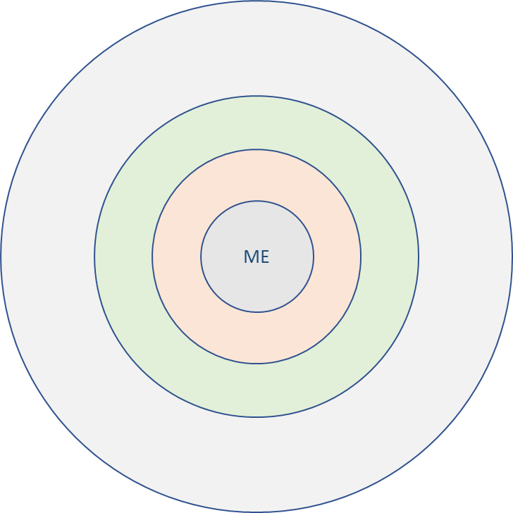
Talk about the people you know:

People who care about me (inner circle)
People I can talk to about anything (second circle)
People I really like being with (third circle)
People I talk to and hang around with (outer circle)
What do you do locally?

