Resilience Documentary

Adverse Childhood Experience (ACE) Study
Resilience tells the story of a US study in 1998 which examined a set of ten types of adverse childhood experience (ACE) and discovered the significant associations with a range of long-term, negative life outcomes across health, education, justice and wider. The ten ACE types used to ascertain a person’s ‘ACE score’ are summarised in the diagram below. These have been measured in subsequent ACE surveys in other areas of the USA and in other countries (but no such surveys have been conducted in Scotland to date). Example ACE survey questions are detailed overleaf.
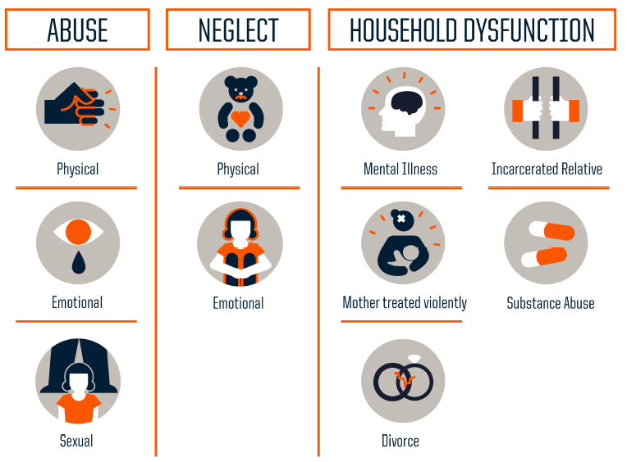
There are other types of childhood adversity (e.g. bereavement, bullying, neighbourhood violence), which are not generally included in ACE surveys, but can have the same negative effects. These additional types of adversity have been explored in other research and some ACE studies are incorporating additional adversities depending on the populations they are looking at.

Personal Support
If you are affected by any of the issues covered in the film there are support services available for Scottish Government employees:
- Counselling and Wellbeing Service (CAWS) – providing practical advice on work and personal issues (further information on Saltire)
- Employee Assistance Programme (EAP) – offering professional support and guidance for colleagues experiencing problems (further information on Saltire)
The Scottish Government also has a Mental Health and Wellbeing Committee and a Mental Health and Wellbeing Network where colleagues can get involved in helping to promote wellbeing in our workplaces by raising awareness of the issues and support available (see section on staff networks on Saltire).
Further Information on ACEs
For further information on ACEs or to discuss policy/practice responses please contact Sara Dodds in the Children & Families Directorate: sara.dodds@gov.scot, x40793.

Example ACE Survey Questions (used in the English and Welsh ACE surveys)

While you were growing up, before the age of 18…

1) Parental separation
…were your parents ever separated or divorced?

2) Domestic violence
…how often did your parents or adults in your home ever slap, hit, kick, punch or beat each other up?

3) Physical abuse
…how often did a parent or adult in your home ever hit, beat, kick or physically hurt you in any way? This does not include gentle smacking for punishment.

4) Verbal abuse
…how often did a parent or adult in your home ever often swear at you, insult you, or put you down or humiliate you?

5) Sexual abuse (the following two items only contribute once to overall ACE score)
- …how often did anyone at least 5 years older than you (including adults) ever touch you – or try to make you touch them - sexually?
- …how often did anyone at least 5 years older than you (including adults) force you to have any type of sexual intercourse (oral, anal or vaginal)?

6) Neglect (the following two items only contribute once to overall ACE score)
- …how true was the following: You didn’t have enough to eat, had to wear dirty clothes, or had no one to protect you?
- …how true was the following: Your parents were too drunk or high to take care of you or take you to the doctor if you needed it?

7) Mental illness
…did you live with anyone who was depressed, mentally ill or suicidal?

8) Alcohol abuse
…did you live with anyone who was a problem drinker or alcoholic?

9) Drug abuse
…did you live with anyone who used illegal street drugs or who abused prescription medications?

10) Incarceration
…did you live with anyone who served time or was sentenced to serve time in a prison or young offenders' institution?

